|  |
| --- |
| DataVersity.jpg |
| **Webinar Presenters: What We Need from You and What You Can Expect as a Webinar Presenter** |
|  |

Contents

Getting Started 3

What We Need From You 3

Short Bio 3

Presentation 3

Presentation Due Date 3

What to Expect & Things to Know 4

Webinar Promotion 4

General Webinar Information 4

What Can Attendees Do? 5

What a Presenter Can Do / Enhancing Presentations 6

General Presentation Points 6

Enhancing Your Presentation 6

# Getting Started

Thank you for sharing your knowledge and becoming a webinar presenter. We have put together some information for you to review. This document covers what we need from you to set you up as a presenter and what to expect from your experience in using our system.

This document will give you highlights and tips of what we need from you before you begin your presentation, what you can expect as a webinar presenter and general help with using the software. If you need additional help and information about presenting, let your contact know.

# What We Need From You

## Short Bio

We need a short biography that includes:

* Your name
* Job Title
* Who you work for
* Work history
* Anything else you want to include that is relevant to your expertise development.
* For an example, see biographies posted to: <http://www.dataversity.net/contributors>

## Presentation

Presentations should be built in Microsoft PowerPoint 1997 or later. If you do not have PowerPoint, please let us know and we can work to convert your files appropriately. The presentation should include:

* Title Page
* Presentation Agenda / Outline
* Presentation
* [Optional slides:
* Information Pages: if you would like to include a page about you or the company you work for, please include it after the Title Page and before the Agenda / Outline.]

## Presentation Due Date

Presentations should be turned in to your contact *one week prior* to the webinar date. This will enable us to upload the presentation, correct any issues in the upload and provide a link for attendees to view the presentation ahead of time if that is part of the process.

# What to Expect & Things to Know

## Webinar Promotion

The webinar will be promoted as an event on [Dataversity.net](http://dataversity.net/). It may be promoted on several pages, but it will definitely be shown on the Education > [Events](http://www.dataversity.net/education/events) page. Dataversity is an online education portal designed to educate and promote those in the field of data management. Your webinar should reach an audience of roughly 35,000 people.

## General Webinar Information

Here are a few general pieces of information for you to know:

* iLinc is the software we use as our Webinar platform (Image F-1).
* Your contact or other assigned leader will upload your presentation and prepare it for viewing.
* We record all webinars to add to our archives on [Dataversity.net](http://dataversity.net/) or to be made into other media forms such as podcasts.

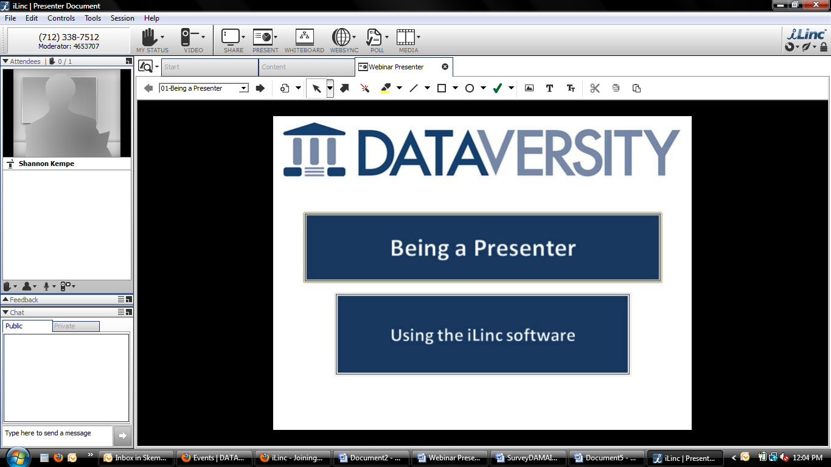

Image F-1

## What Can Attendees Do?

Here are a few pointers as to what attendees can and cannot do within a session:

* Attendees will be muted and will not be able to speak to the presenter unless an exception has been made .
* Attendees will have the option to chat (type) with each other and the presenter to ask their questions (Image F-2 and F-3).
  + Attendees can make their chat “Public” enabling the presenter and all attendees to view the chat.
  + Attendees can make their chat “Private” enabling only the person they select for the chat to see their comment.
  + Presenters can choose to respond by typing their answer in the chat space or verbally so all can hear the question and answer.

 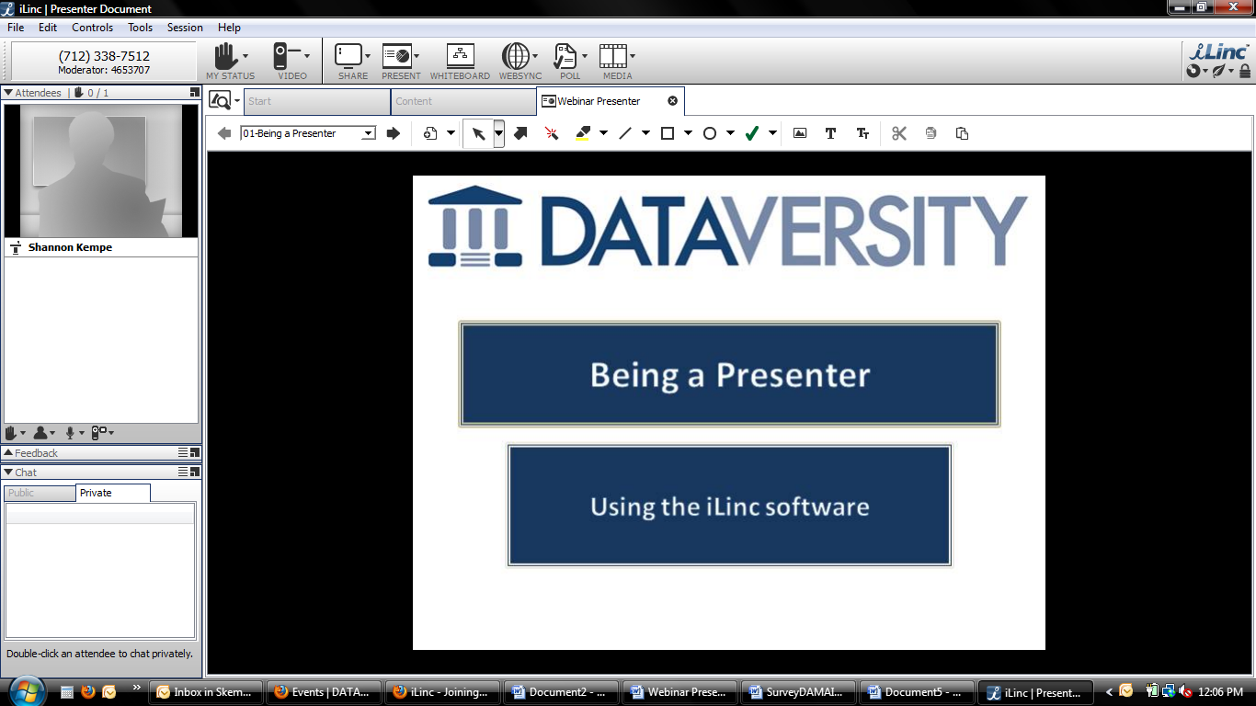

Images F-2 and F3

## What a Presenter Can Do / Enhancing Presentations

### General Presentation Points

* To simply move through your slides, simply use the up ↑ and down ↓ arrows on your keyboard.
* Your contact or another leader will log in with you to the session, introduce you to the attendees and give you control of the presentation within the software.

### Enhancing Your Presentation

To enhance your presentation and use the additional features provided, there are 5 key areas to know as a presenter (Image F-4). Let your contact know if you want to log in ahead of time to look through these areas to familiarize yourself with them.

1. Your Status and Video Controls
   1. To enable attendees to view you as you present, to activate your webcam, click the Video icon and then “Display Video”.
2. Presentation Options
   1. “Share” your desktop.
   2. “Present" takes you to the preloaded content such as your PowerPoint.
   3. “Whiteboard” opens an interactive whiteboard.
   4. “Websync” enables you to open an interactive webpage.
      1. Attendees will be able to scroll through and enter any information (e.g. fill out an online form) independently from each other.
   5. “Poll” enables you to create a poll for attendees to fill out.
      1. This option enables you to save the poll.
   6. “Media” enables you to enter a URL to open and play a video.
3. Presentation Enhancements
   1. When your presentation is up, you will see various controls that enable you to treat your presentation like a whiteboard.
   2. Just click the icon you wish and hold the left mouse button down to activate it and make it visible to attendees.
   3. To get back to the standard pointer attendees *cannot* see, click the arrow icon pointing in the upper left (Image F-5).
4. Controls over Attendee status
   1. It is very rare presenters will have to use this area during our webinars because of how they are set up, but in general presenters should be aware of it.
   2. Attendees have the option of raising their hand, applauding, steping away or giving a thumbs up or thumbs down – this section enables the presenter to clear the status of everyone or change the status.
      1. Presenters can do this too from area **1**, “My Status”.
      2. Hand raising is typically used in sessions where the presenter can un-mute the individual attendee which is not typically an option within our webinars.
5. Quick Feedback Questions for In-Session
   1. This is a great way to enhance your presentation. You can ask attendees a question and not only see the results, but share them with everyone immediately.
   2. To use:
      1. Ask your question verbally and then click the lines on the left of the Feedback bar (Image F-6).
      2. Select one of the answer types from the middle of the popup from “Pace” to “A/B/C/D” (Image F-7).
         1. You and attendees will immediately see the answer type and can begin to click their desired answer.
      3. To share the answers with the attendees, click the lines icon again and click “Share” at the top.
      4. To clear the answers, click the lines icon again and click “Clear”.



**2.**

**3.**

**4.**

**5.**

**1.**

Image F-4



Figure F-5



Image F-6

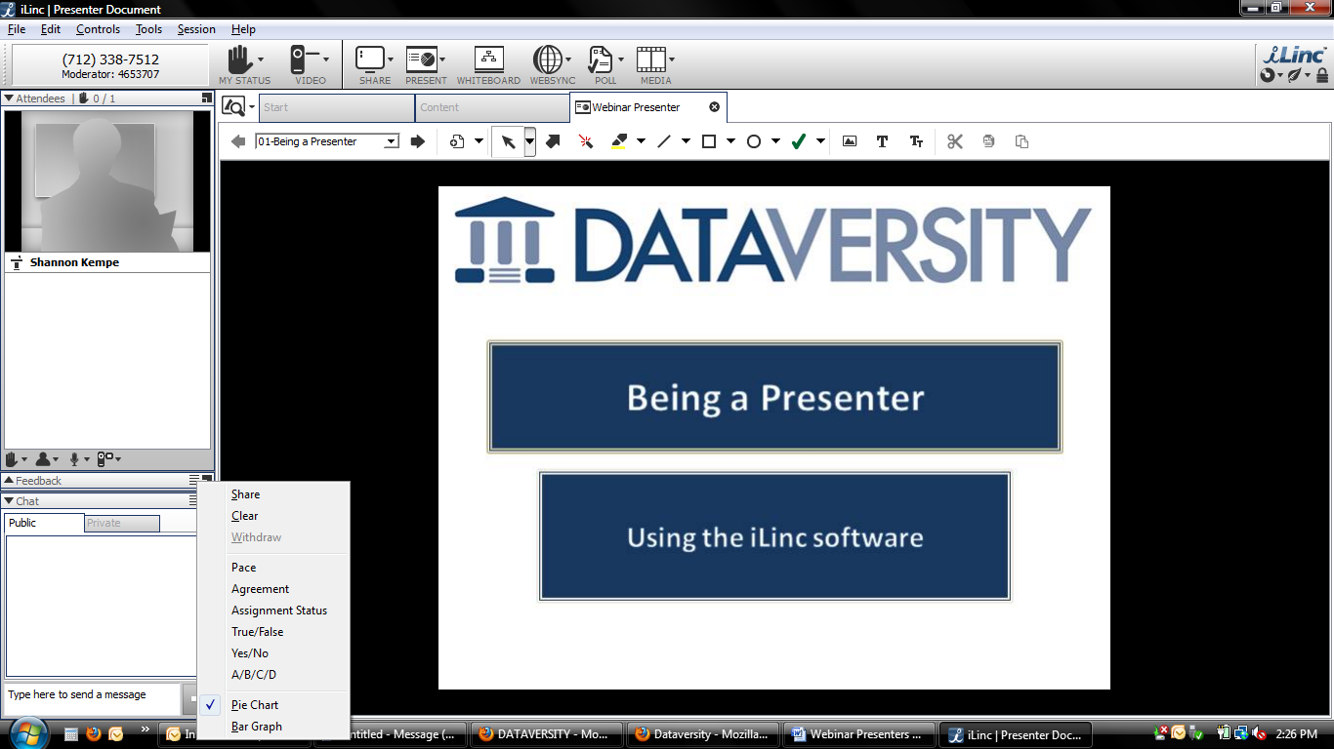 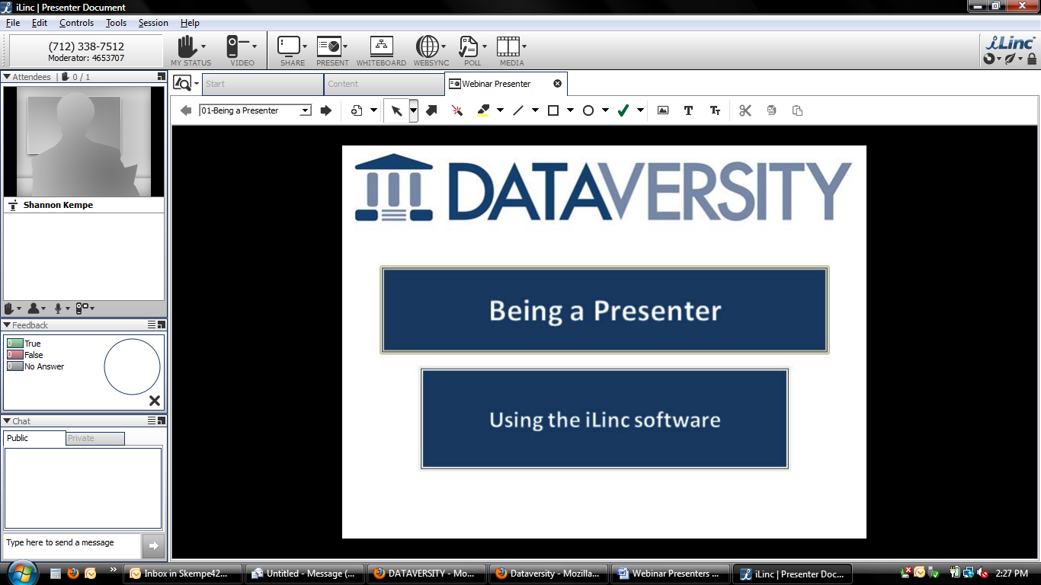

Image F-7 Image F-8