|  |
| --- |
| DataVersity.jpg |
| **How to Create, Publish and Modify an Article or Blog on Dataversity.net** |
|  |

|  |
| --- |
| Shannon Kempe  3/24/2011 |

Table of Contents

Getting Started 3

How to Create a New Article or Blog 5

How to Find the “Add New Post” Page 5

Filling Out the Title and Text 7

The Title 7

The Text 8

Uploading Images and other Media 9

Inserting Image into Post versus Featured Images 11

Publishing Your Post 12

Categories 13

Article Categories 13

Blog Categories 13

SEO Tags 15

Featured Images 16

Publishing in the Future 17

Modifying an Existing Article 19

# Getting Started

Welcome to [Dataversity.net](http://dataversity.net/), an online education portal designed to educate and promote those working in the field of data management. We are excited to welcome you as one of our contributors.

To get started, you will receive a Username and Password for the site. If you do not receive an email with this information, please email [support@dataversity.net](mailto:support@dataversity.net). You can create your own login, however an administrator needs to set your permission levels to enable you to create, modify and post articles.

Once your login is created, you can log into the site from one of two places (Image F-1):

1. The left hand side of the screen in the left sidebar
2. From a menu tab at the top right hand side of the screen
   1. Click on the tab and a dropdown will appear with spaces to place your Username and Password

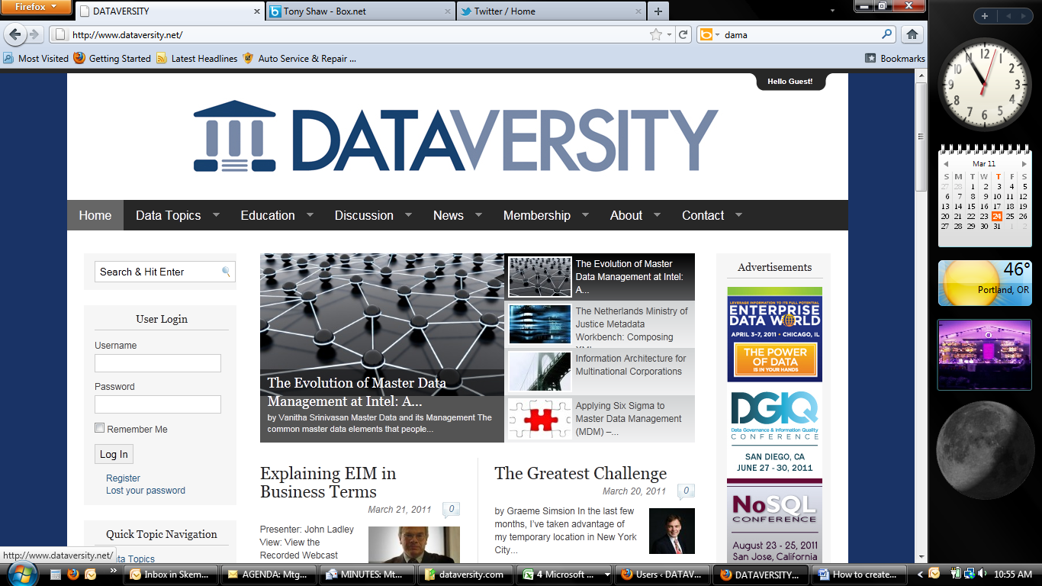

**2.**

**1.**

Image F-1

Once logged in, the control panel in the left sidebar will change to show you are logged in and to give you appropriate options to access the tools to create, modify and post an article (Image F-2).

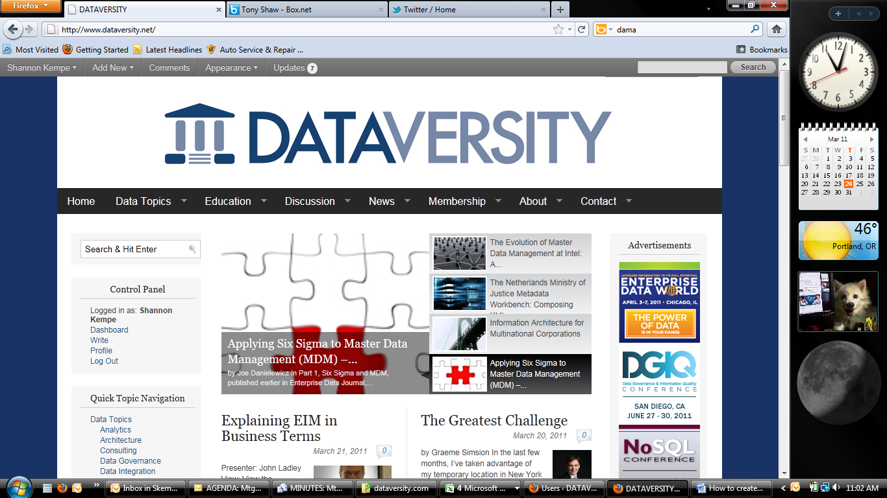

Image F-2

If you do not see the option for “Dashboard” or “Write” under your name, please contact [support@dataversity.net](mailto:support@dataversity.net).

In addition to generating the login for you, the administrator of <http://dataversity.net> will need a photo and short bio from you to set up your “Contributor” page. Once complete, you will receive a link to your page.

You are now set up to create, modify and post an Article to <http://dataversity.net>.

# How to Create a New Article or Blog

## How to Find the “Add New Post” Page

To create a new article, you can either click on “Dashboard” or “Write” on the left hand side of the screen within the Control Panel (Image F-3).



Image F-3

If you click on “Dashboard,” you will go to the site’s Dashboard page showing all options available to you. To create a new post, click on “Posts” on the left hand side (Image F-4).

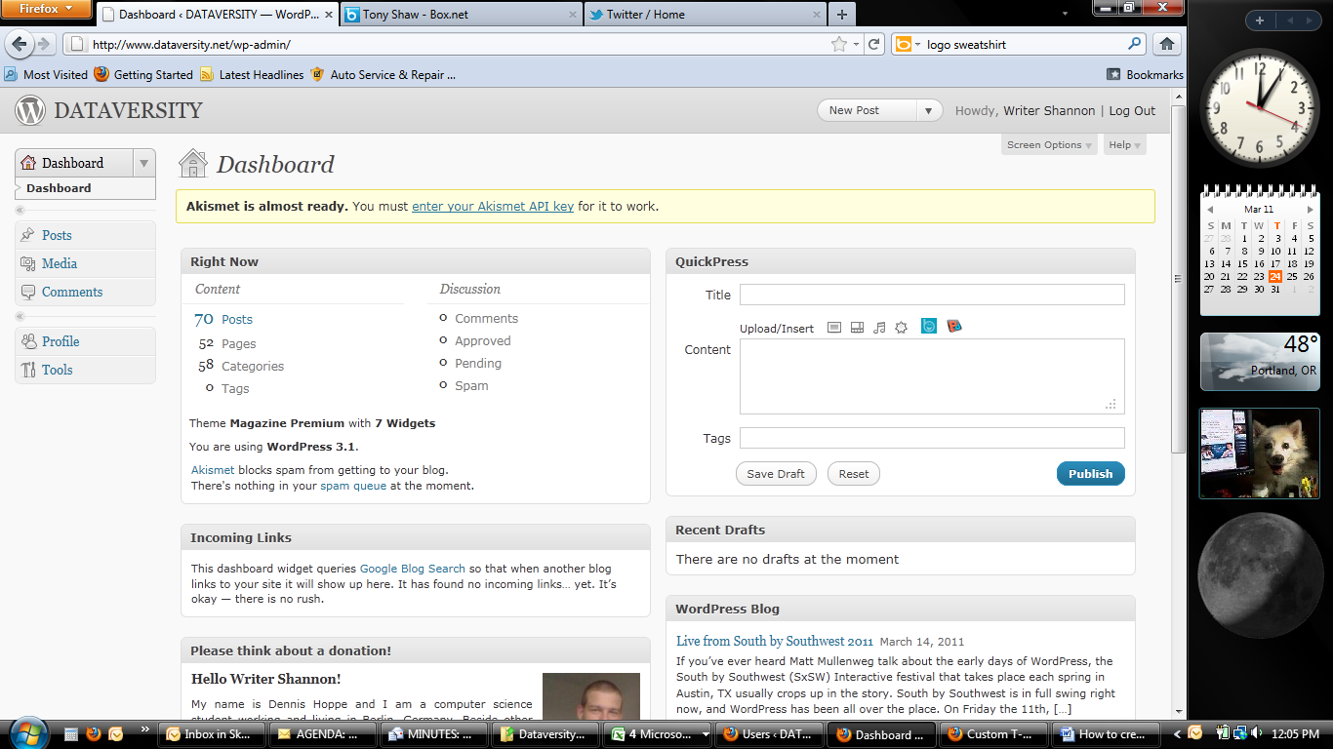

Image F-4

This will take you to a list of all Posts and create a dropdown under “Posts” on the left hand side. To create a new post, click “Add New” on either (Image F-5):

1. The left hand side under “Posts”
2. The radial button at the top

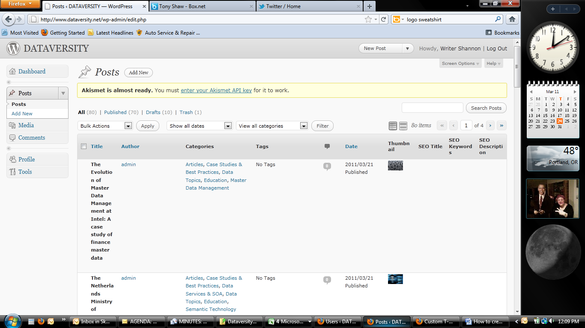

**2.**

**1.**

Image F-5

This will take you to the page needed to begin a new Article.

If you click “Write” instead of “Dashboard” from the Control Panel off the Home page of the website, you will go directly to the page needed to begin a new Article (Image F-6).

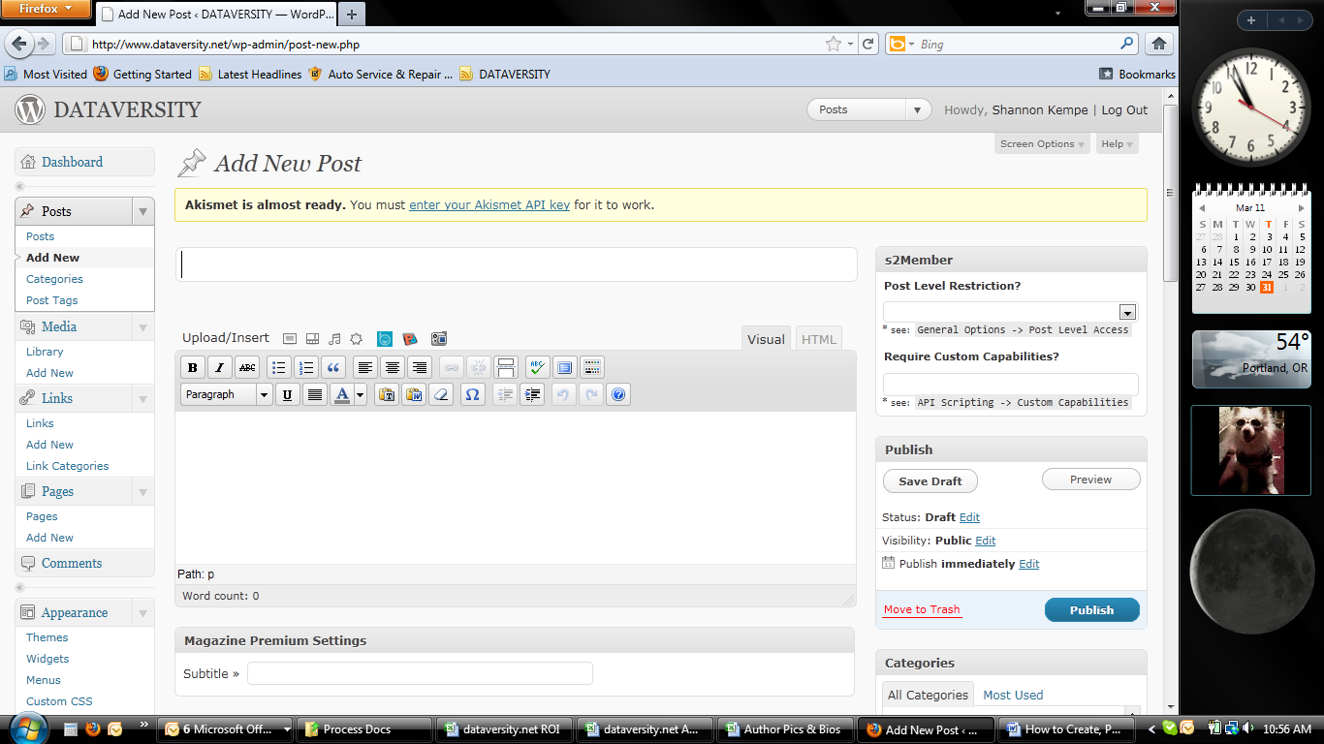

Image F-6

## Filling Out the Title and Text

There are five key areas to know within this page in order to fill out the article title and text (Image F-7):

1. Place to enter the title of the article
2. Icons to upload images, video, audio and media into your article
3. Toolbar with icons to format your text and paragraphs
4. Place to enter the text of the article
5. Save Draft radial button to save your work
   1. NOTE: Don’t click “Publish” until you have read the “Publishing Your Article” section.



**5.**

**4.**

**3.**

**2.**

**1.**

Image F-7

### The Title

To create the title, the only thing to be done is type the title in area **1** of the “Add New Post” page. To save the title and draft of your new article, click area **5**, the “Save Draft” radial button.

### The Text

Before you write anything, it’s important to start with a byline. The first line should be: by [Your Name]. You then want to hyperlink your name to your bio page. You should have received a link to your page. If you can’t find it, go to the home page of <http://dataversity.net> and you should see your name listed on the lower left hand side of the screen under “Quick Info Navigation.” Click on your name. Highlight the URL that populates at the top of the screen and copy the link.

To hyperlink your name in the text, you will need to highlight your name and click on the icon in area **3** that looks like a chain to hyperlink your name to your bio page (Image F-8).



**3.**

Image F-8

A new, small screen will pop up and ask you to type in the URL. Paste the copied URL from your bio page into this section. There is no need to title it. Click the box underneath to “Open link in a new window/tab” and then press “Add Link” in the bottom right (Image F-9).

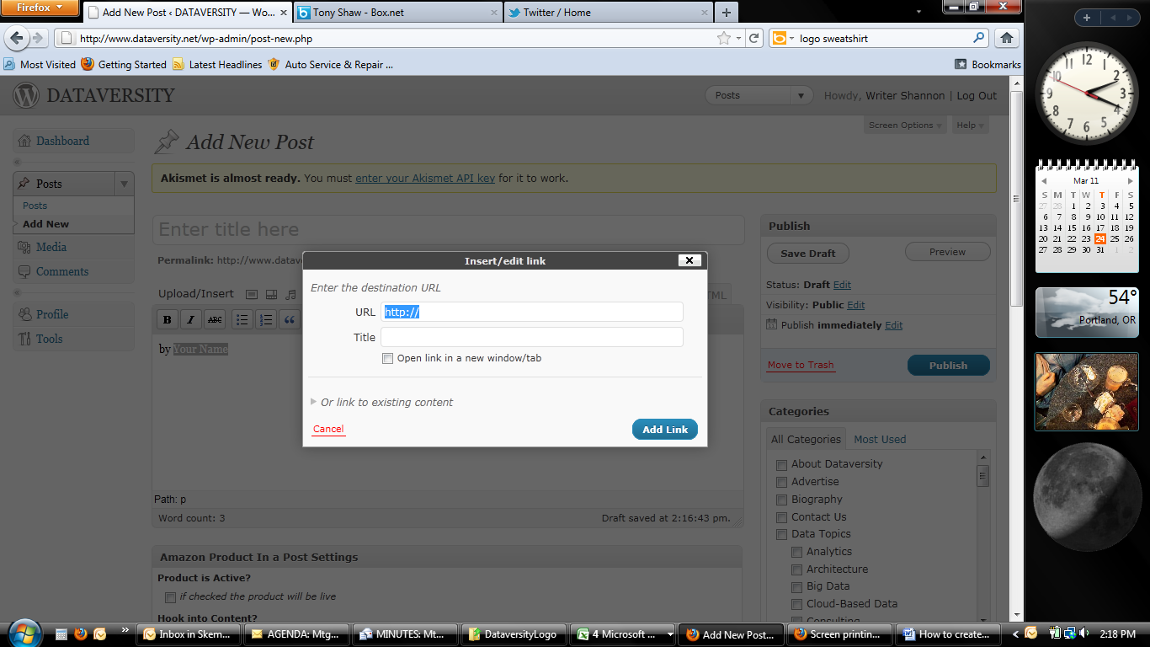

Image F-9

To write your article, you can either type your text within area **4** or you can create in another application such as Word and then copy-paste the article into area **4** once completed.

## Uploading Images and other Media

Area **2** offers icons that enable you to upload images, video and other media types into your article. Hover (place) your mouse over the icon to determine what it is designed to upload (a small pop up text will show you what it is). Click the desired icon and a new screen will pop up with upload steps. Uploading procedures are pretty standard, just like other software. If you have issues or questions, please email [support@dataversity.net](mailto:support@dataversity.net).

To add images to your article, there are three options readily available to you:

1. Click the icon in area **2** that says “Add Photo via Photo Dropper” (Images F-10 and F-11)
   1. This gives you access to free photos
      1. **NOTE:** you must include the cc byline that comes with it.
   2. Type in a keyword for the type of photo you are looking for, and a selection of photos with that keyword will appear for you to browse through.
2. Scroll through the Dataversity Media Library
   1. Click the WordPress image icon (Image F-12) instead of the PhotoDropper
   2. Select the “Media Library” tab (Image F-13)
3. Upload your own photos
   1. Click the Wordpress image icon (Image F-12)
   2. The popup window will take you automatically to the screen to upload images (Image F-14)



**2.**

Image F-10

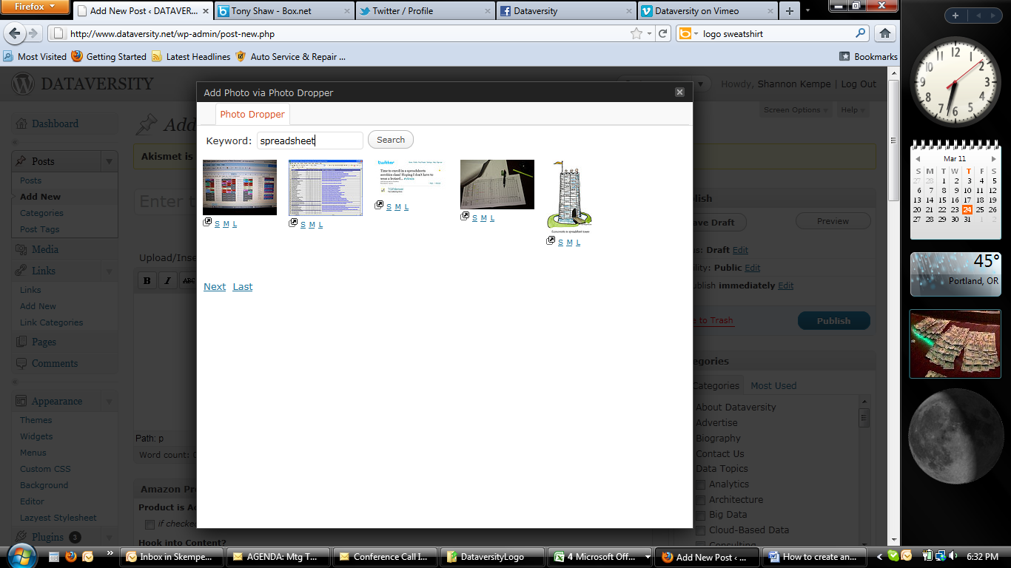

Image F-11

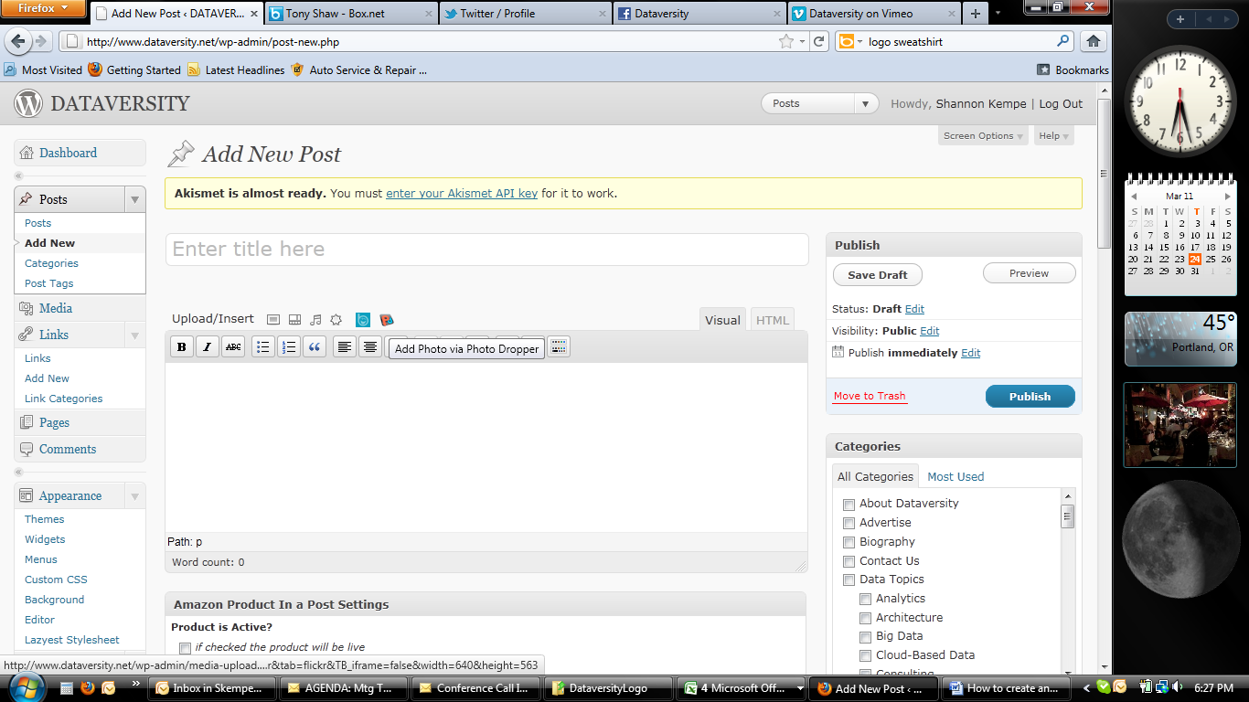

Image F-12

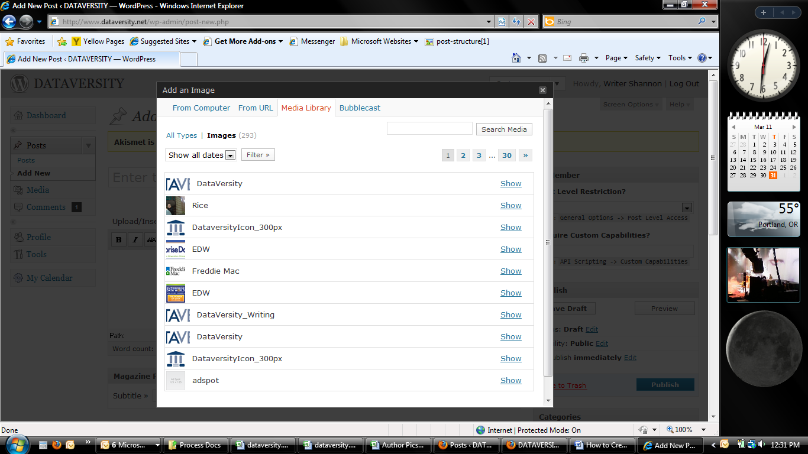

Image F-13

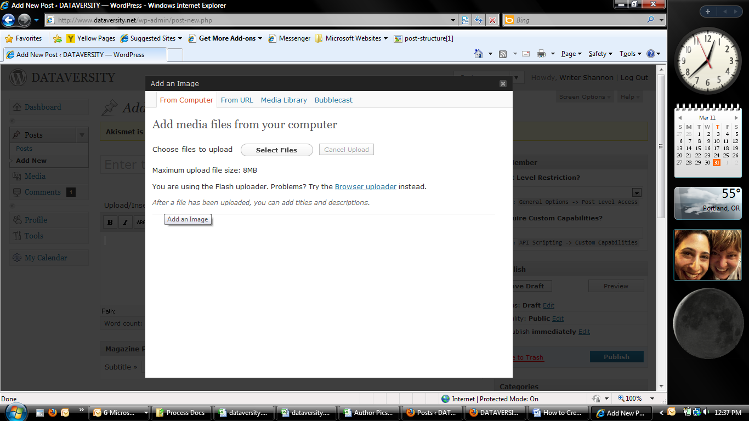

Image F-14

### Inserting Image into Post versus Featured Images

When uploading an image, you will be given the options (Image F-15):

1. “Edit Image” will appear as a radial button underneath. When clicked, you can crop and scale your image as desired.
2. Set the alignment of the image to populate in the article.
3. Size the image
4. Image placement
5. “Insert into Post” will insert into area **4** where your cursor was last within your text.
   1. NOTE: once you click this, the pop-up screen will disappear and go to the image in your post
   2. “Use as featured image” – by clicking this, the image you have selected will appear in the thumbnails and slideshows on the website in all previews of your article.

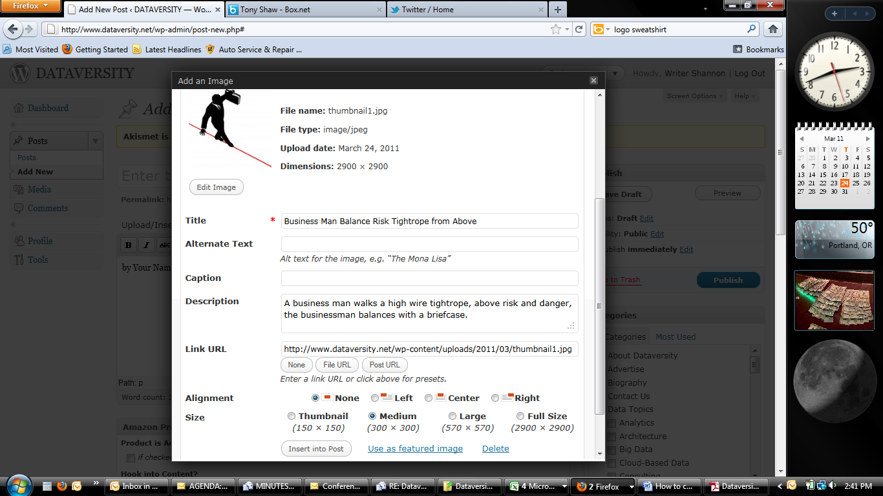

**4.**

**3.**

**2.**

**1.**

Image F-15

# Publishing Your Post

To publish your article or blog, there are a few things to do before you click the blue “Publish” radial button.

1. Select the appropriate Categories your article should be published under
2. Add any SEO (Search Engine Optimization) Tags you think appropriate for readers to search under to find your article
3. Set a “Featured Image”
4. Do not change or set s2Member level permissions unless specifically asked to do otherwise for your specific blog or article (Image F-16)



Image F-16

## Categories

The “Categories” section can be found on the lower right hand side of the screen (Image F-17). It is *very important to select the correct categories* in order for your post to be visible in the appropriate areas of the website.

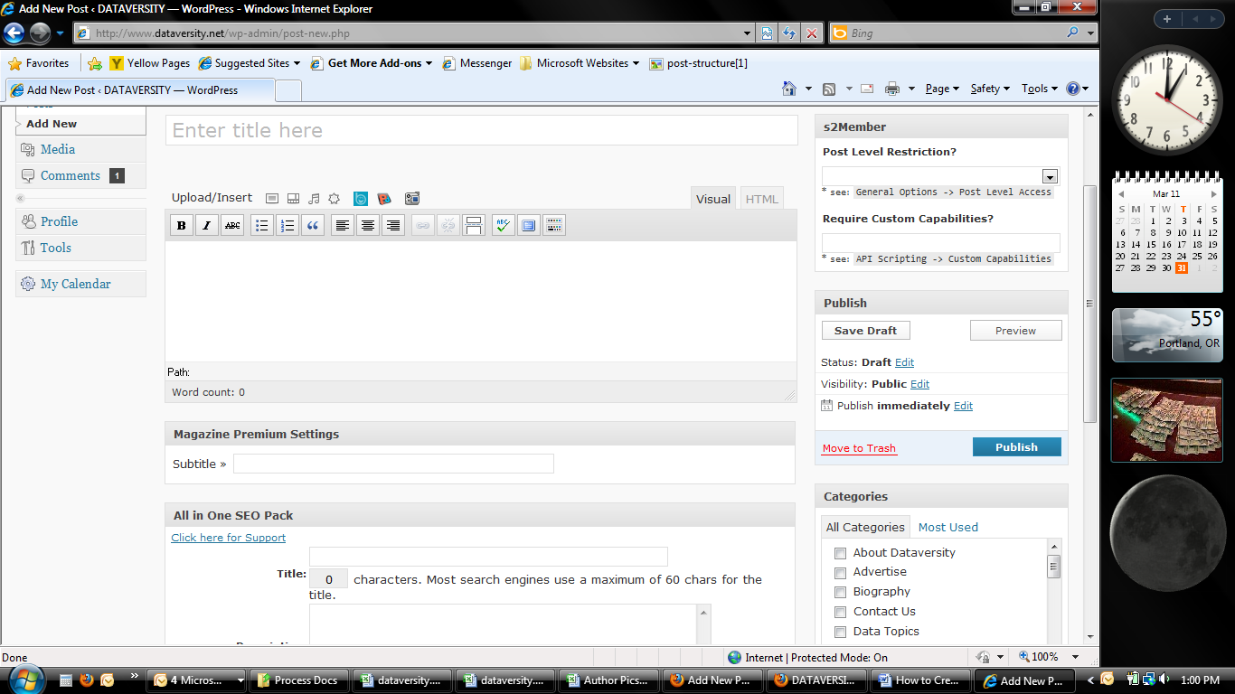

Image F-17

### Article Categories

To select a category, just click the box next to it so it shows a checkmark. For an *article*, you will need to select the following:

* Data Topics
  + [The appropriate subtopic(s) under Data Topics]
* Education
  + Articles

### Blog Categories

To select a category, just click the box next to it so it shows a checkmark. For a *blog*, you will need to select the following:

* Data Topics
  + [The appropriate subtopic(s) under Data Topics]
* Discussion
  + Blogs
    - [Your Name]

If you have questions about which Categories to assign, email [support@dataversity.net](mailto:support@dataversity.net).

## SEO Tags

At the foot of the page when you scroll all the way down, is a section titled “All in One SEO Pack” you will want to fill out to help readers find your article (Image F-18).

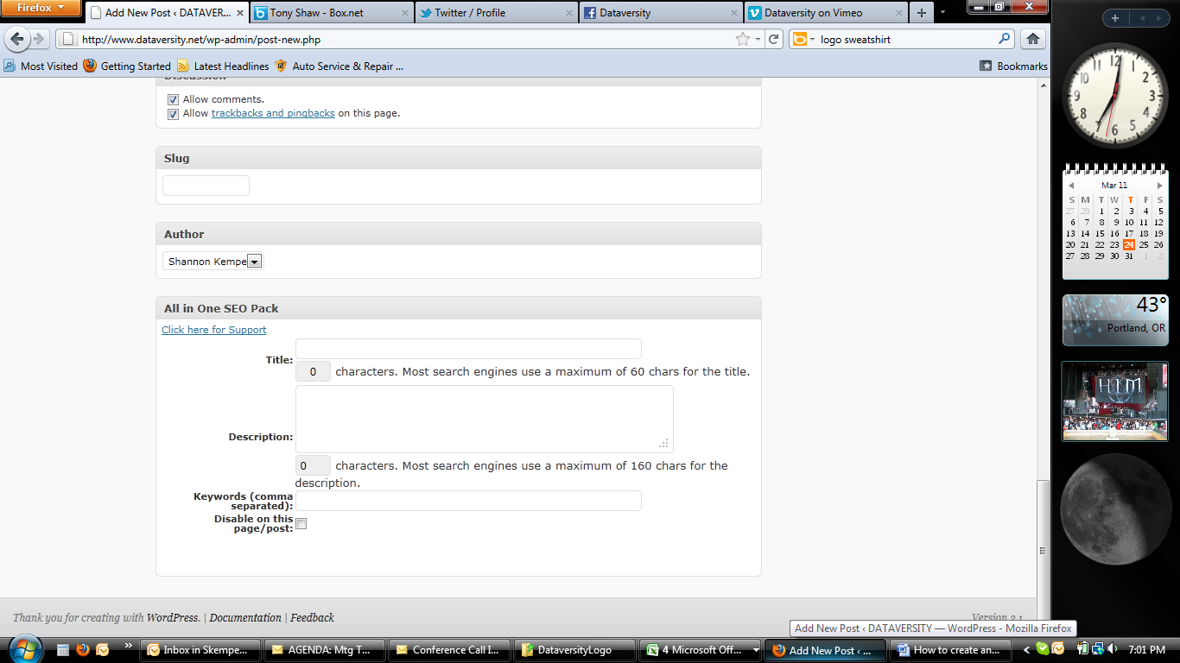

**1.**

**3.**

**2.**

Image F-18

1. In the “Title” section, simply retype the title of your article.
2. In the “Description” section, type a very brief description of your article.
3. In the “Keywords” section, type in keywords that readers might type into a search engine to find information such as your article provides. Separate all keywords or phrases with commas.

For help with SEO tags, email [support@dataversity.net](mailto:support@dataversity.net).

## Featured Images

Featured images are those that appear next to a sample of the article on the home page or larger category page. If you do not set a featured image, the first image within your article will be the one the site automatically selects. If that’s the one you want to use, you have no further action. If you would like to specify a feature image, you can do so in a section about half way down on the right hand side (Image F-19).

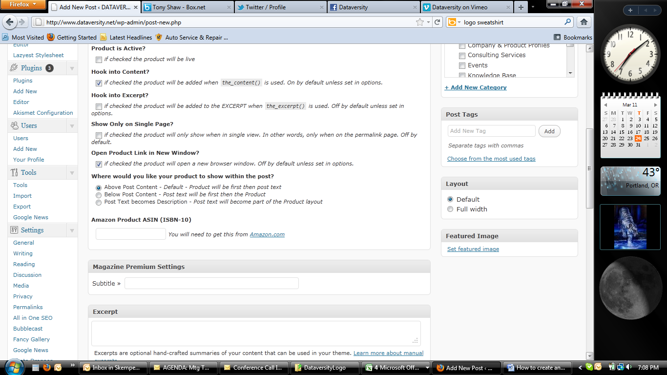

Image F-19

Click on “Set Feature Image” and follow the steps within the popup screen to upload your preferred image.

When the image has uploaded, you must click on “Use as Feature Image” at the bottom of the image upload page (Image F-20). Once you have clicked that, you can close the popup screen without doing anything else.



Image F-20

For help with Feature Images, email [support@dataversity.net](mailto:support@dataversity.net).

## Publishing in the Future

If you’ve completed your article, but want to publish it at a later time for whatever reason, you may schedule an article to be published at a future date and even time. On the right hand side of the screen near the top of the page in the “Publish” section is a line that states “Publish **immediately** Edit” (Image F-21).

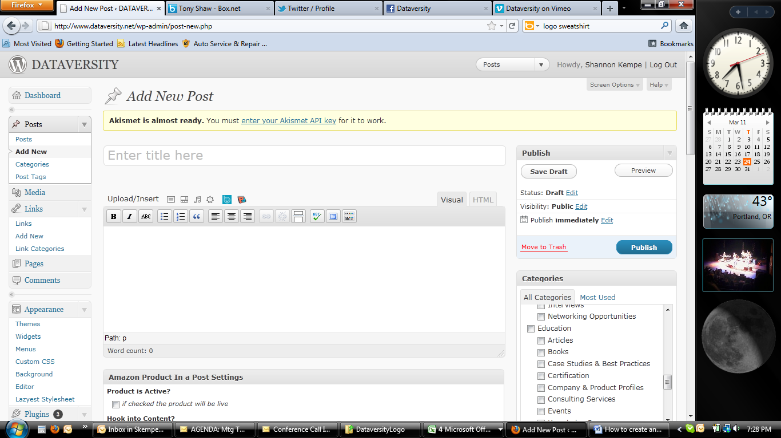

Image F-21

If you click on “Edit,” you will get a section that appears giving you an option to change the date and time your article will be published (Image F-22). Once you’ve selected the date and time desired, click “OK”.

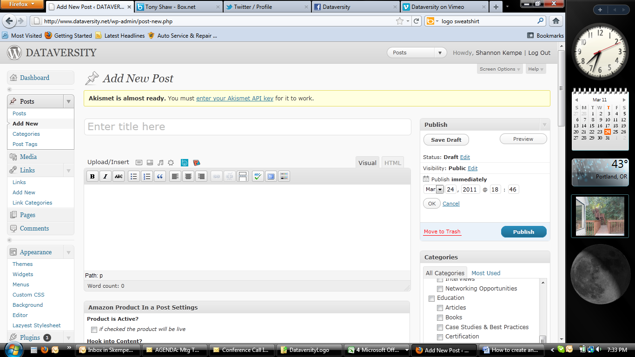

Image F-22

Congratulations! You’ve been through all the steps and you’re ready to make your article public on Dataversity.net. You are now ready to click the blue “Publish” radial button (Image F-23).

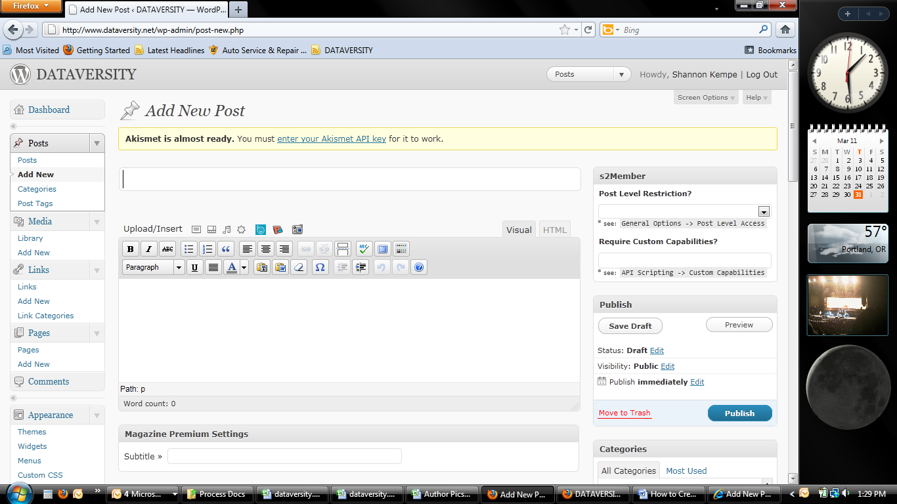

Image F-23

For issues with publishing your article, email [support@dataversity.net](mailto:support@dataversity.net).

# Modifying an Existing Article

From the <http://dataversity.net> home page, log into the site and then select “Dashboard” under the Control Panel. From the Dashboard page, select “Posts” (see “Getting Started” section for details and images).

A list of all existing posts will appear on the “Posts” page. These will include blogs, webinars and other types of posts in addition to articles.

To help sort through the list, you can filter the list to include only articles or any other category (Image F-24). Select the category you wish from the dropdown, and then click the “Filter” radial button.

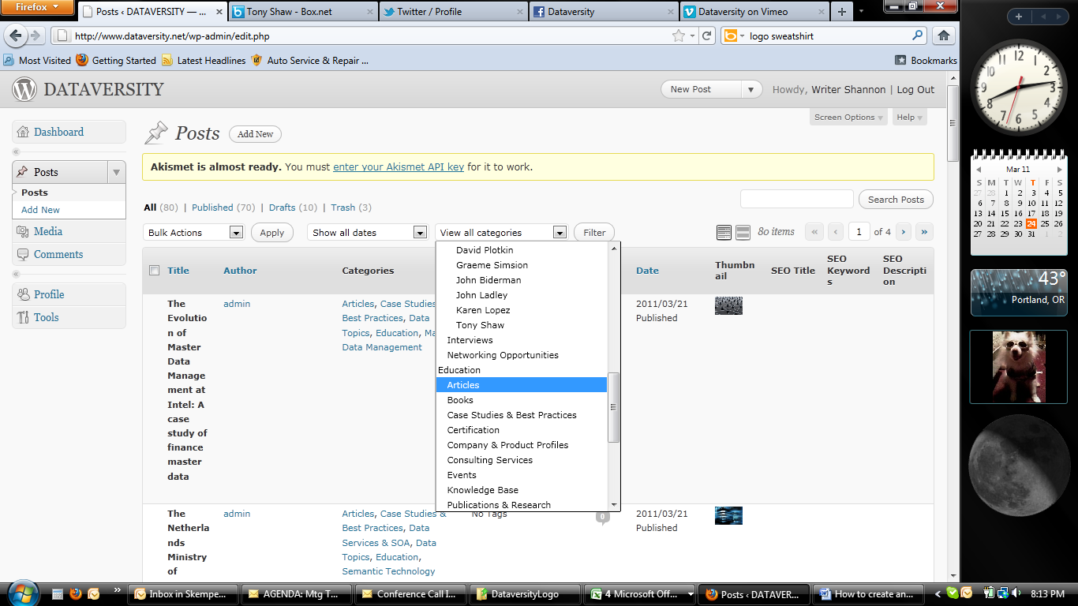

Image F-24

In the menu bar you can sort the posts by Title, Author or Date by clicking on those menu names (Image F-25).

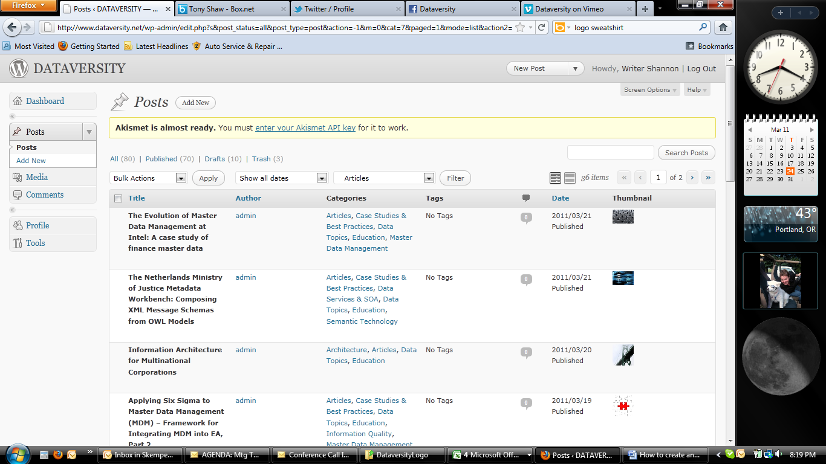

Image F-25

Find the article you wish to edit, and you can either click on the title itself to take you to the article or when you hover (place) your mouse over the title you will see options appear below it (Image F-26).

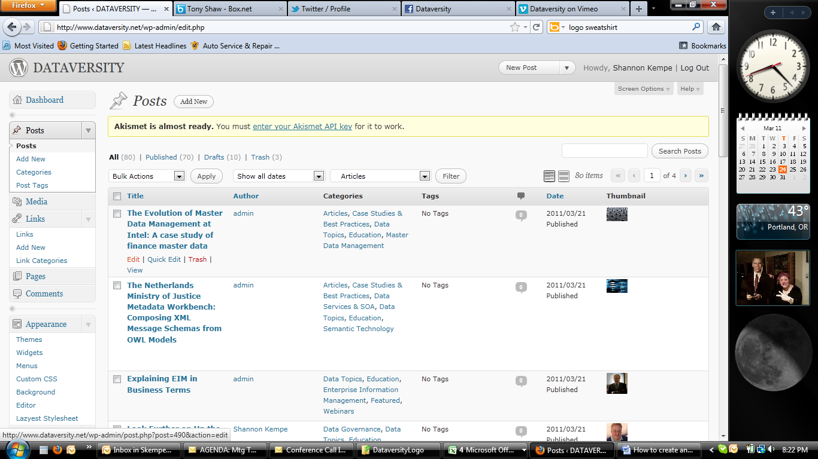

Image F-26

Click “Edit” to edit the body of the article itself or “Quick Edit” to modify the publish date, title or categories the article is published under. If you click “Trash” it will delete your article. “View” will take you to the viewable page by readers.

If you click “Edit,” it will take you back to the same page you created the article in. Instead of the blue “Publish” radial button however, you will have a blue “Update” radial button to push once you are done making your changes (Image F-27).

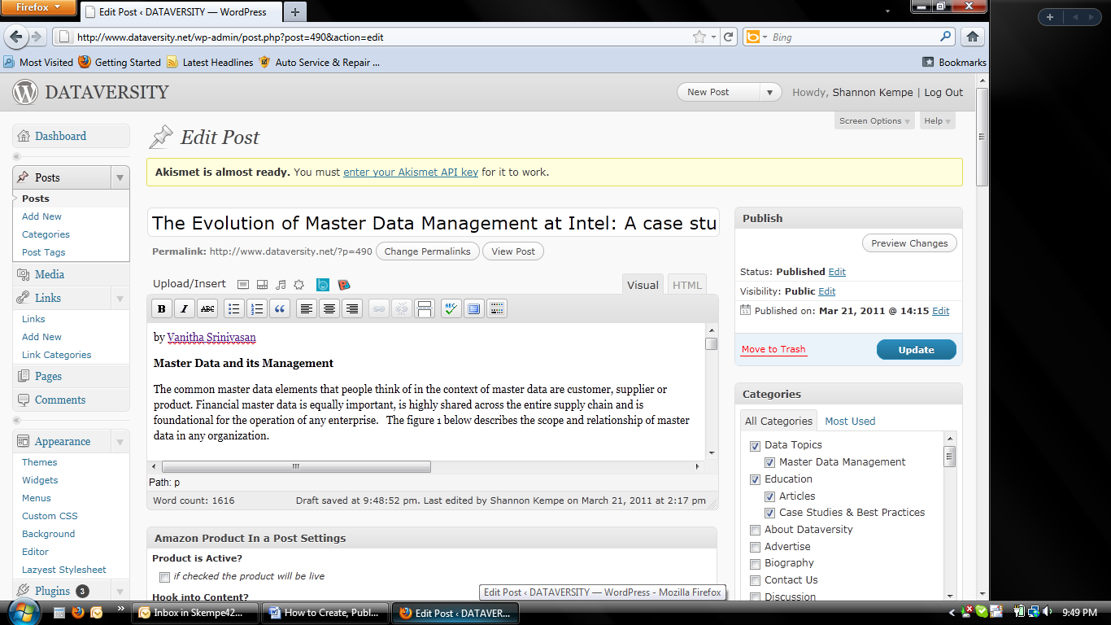

Image F-27

For help modifying your post, email [support@dataversity.net](mailto:support@dataversity.net).